
Ch. de Savoie 16

1090 La Croix-sur-Lutry Madame
Stefania Georgiadis
Phone : 079 / 353 70 32 Im Gjuch 20
Email : info@offaxis.ch 8143 Stallikon

Your purchase at OffAxis

Hello,

We thank you for your trust and your order with our company.

We wish you a very beautiful winter and look forward to seeing you soon on our e-shop or at one of our events.

To not miss our special offers and various events throughout the year, sign up for our newsletter at www.offaxis.ch

A small comment on Google would make us very happy 😉 👍🏻

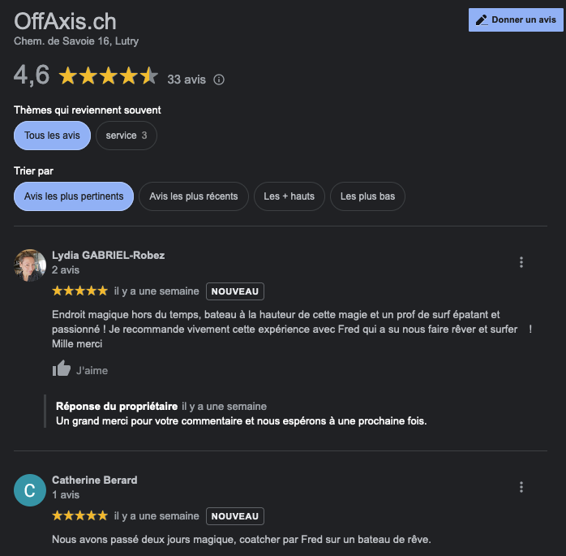

Best Regards

OFFAXIS.CH

